**An Efficient Deep neural network architecture to Classify   
Breast Cancer using Breast MR images.**

**A Project Report submitted in partial fulfillment of the requirements for the award of the degree of,**

**BACHELOR OF TECHNOLOGY IN**

**COMPUTER SCIENCE AND ENGINEERING**

Submitted by:

|  |  |
| --- | --- |
| **Mathew K Sojan** | **322010302008** |
| **M Chaitanya Kumar** | **322010302002** |
| **S Vignesh Vishnu** | **322010302046** |
| **S Bharath** | **322010305006** |

**Under the esteemed guidance of**

**Dr. Dayanand Lal N**

**ASSISTANT PROFESSOR**



**Department of Computer Science & Engineering,**

**GITAM SCHOOL OF TECHNOLOGY**

**GANDHI INSTITUTE OF TECHNOLOGY AND MANAGEMENT**

**(Deemed to be University) Bengaluru Campus.**

**April 2024**

**(Deemed to be University)**



**CERTIFICATE**

This is to certify that the project report entitled **“An Efficient Deep neural network architecture to Classify the Breast Cancer using breast MR images”** is a bonafide record of work carried out by **Mathew K Sojan(322010302008), M.Chaitanya Kumar(322010302002), S.Vignesh Vishnu(322010302046), S.Bharath(322010305006)**  submitted in partial fulfillment of requirement for the award of degree of **Bachelors of Technology in Computer Science and Engineering**.

**Project Guide. Head of the Department.**

**SIGNATURE OF THE GUIDE SIGNATURE OF THE HOD**

**Dr. Dayanand Lal N**

Assistant Professor

**Dr. VamsidharYendapalli,**

Professor.

#### (Deemed to be University)



**DECLARATION**

We, hereby declare that the project report entitled **“An Efficient Deep neural network architecture to Classify the Breast Cancer using breast MR images”** is an original work done in the **Department of Computer Science and Engineering, GITAM School of Technology, GITAM (Deemed to be University)** submitted in partial fulfillment of the requirements for the award of the degree of **B.Tech.** in Computer Science and Engineering. The work has not been submitted to any other college or University for the award of any degree.

#### Date:25/03/24

|  |  |  |
| --- | --- | --- |
| **Registration No(s).** | **Name(s)** | **Signature(s)** |
| **322010302008**  **322010302002**  **322010302046**  **322010305006** | **Mathew K Sojan**  **M Chaitanya Kumar**  **S Vignesh Vishnu**  **S Bharath** |  |

**ACKNOWLEDGEMENT**

The satisfaction and euphoria that accompany the successful completion of any task would be incomplete without the mention of the people who made it possible, whose consistent guidance and encouragement crowned our efforts with success.

We sincerely thank **Dr. Y. Vamshidhar,** HOD, Department of Computer Science and Engineering, Gandhi Institute of Technology and Management, Bengaluru for the immense support given to us.

We express our gratitude to our project guide **Dr. Dayanand Lal N, Assistant Professor**, Department of Computer Science and Engineering, Gandhi Institute of Technology and Management, Bengaluru, for their support, guidance, and suggestions throughout the project work.

Student Name’s Registration No.

Mathew K Sojan 322010302008

M Chaitanya Kumar 322010302002

S Vignesh Vishnu 322010302046

S Bharath 322010305006

|  |
| --- |
|  |
|  |
|  |

**ABSTRACT**

Breast cancer is one of the most common cancers, especially among women. If diagnosed early, the treatment process can be easier and more successful. For this reason, it is of great importance to reach the right result quickly in the scans and analyses performed by the doctors. But traditional ways of analyzing and classifying breast cancer are quick but may not be accurate all the time. An accurate and quick method to analyze and classify breast cancer according to the seriousness of the case can be making a huge difference in the results of the therapy provided. DNN is a deep learning technique that resembles the functioning of the human brain and works efficiently too. DNNs' ability to extract features from unlabeled and unstructured data makes them more efficient in analyzing breast cancer for classification. In this paper, a few most used and efficient DNN models are discussed and tested on breast cancer classification.

All the Magnetic Resource(MRI) images from the data set, “Categorized Digital Database for Low energy and Subtracted Contrast Enhanced Spectral Mammography images”, are used to train and test the models in the paper. The results of the models are observed and they suggest that Inception V2 produces the best result of 96.47 in the classification of breast cancer images in the data set. Inception V2 is one of the Inception module families which has the advantage of inception modules being reused, but inception v2 is highly affected by overfitting. This paper uses weight decay and dropout methods for the removal of overfitting

### TABLE OF CONTENTS

|  |  |
| --- | --- |
| **Title** | **Page No.** |
| Declaration | I |
| Acknowledgement | II |
| Abstract | III |
| Table of Contents | IV |
| List of Figures | VII |
| List of Tables | VII |
| 1.INTRODUCTION   * 1. Breast Caner   2. Traditional Methodologies   3. Use of Magnetic Resonance Images   4. DNN and Breast Cancer Analysis | 1 |
| 2. LITERATURE SURVEY | 3 |
| 3. PROJECT DESCRIPTION | 3 |
| 4. SOFTWARE AND HARDWARE SPECIFICATIONS | 9 |
| 4.1 Hardware Requirement | 9 |
| 4.2 Software Requirement  4.3 Libraries | 9 |
| 5. PROBLEM DEFINITION | 10 |
| 5.1 Objectives | 11 |
| 6. ARCHITECTURE | 12 |
| 7. IMPLEMENTATION | 12 |
| 8. PROGRAM CODE | 18 |
| 9. EXPERIMENTAL RESULTS | 20 |
| 10. CONCLUSION | 16 |
| 11. FUTURE WORK | 19 |
| REFERENCES | 23 |
|  |
|  |

1. **Introduction**
   1. **Breast Cancer:**

Breast cells can evolve into some types of cancer, including breast cancer. Breast cancer frequently causes mortality in millions of women globally. Breast cancer is third among the many cancer kinds in terms of frequency. Lung, brain, and other cancers are among the many types of cancer. The survival and effectiveness of breast cancer treatment depend heavily on early identification. Breast cancer is frequently identified by physical examinations, mammography, and biopsies. The quickest and easiest method to find breast cancer is a physical examination. During a physical examination, a doctor or other healthcare professional will check the breasts for any lumps, bumps, or changes. The lymph nodes under the arms could also be examined for any enlargement.[1]

* 1. **Traditional Methodologies:**

A physical examination is a crucial initial step in finding any anomalies that may call for more testing, even if it cannot diagnose breast cancer on its own. A low-dose X-ray treatment called mammography creates images of breast tissue. It is the most used technique for spotting breast tissue alterations that can point to the presence of a tumour. Women over 50 should get mammograms, and those who are at higher risk for breast cancer may need to start screening earlier. A biopsy is a technique where a tiny sample of breast tissue is removed for analysis. Other types of biopsies include surgical biopsies, which take a bigger sample of tissue while the patient is under general anaesthesia, and thin-needle biopsies, which remove a smaller sample of tissue.[2]

* 1. **Use of Magnetic Resonance images:**

Using radio waves and a powerful magnetic field, magnetic resonance imaging (MRI), a non-invasive diagnostic technology, produces detailed images of the interiors of organs and human tissues. When mammography or ultrasound are unable to make a precise diagnosis, MRI has emerged as an essential tool for diagnosing breast cancer. MRI can detect invasive breast cancer because it can spot areas of abnormal tissue growth that other imaging methods might miss. It aids in determining the stage of breast cancer in addition to picking up cancer in the opposite breast. Deep neural networks (DNNs), a type of artificial intelligence, have showed promise in improving the accuracy of breast cancer diagnosis. MRI pictures are just one of the vast amounts of data that DNNs

**2023-2024**

**Department of CSE, GST, Bengaluru**

## 1.4 DNN and Breast cancer analysis:

Recent studies have shown that, after being trained on big datasets of MRI images, DNNs may correctly classify breast cancer. These algorithms enable earlier detection and more accurate diagnosis because they can detect subtle abnormalities in the appearance of breast tissue that are invisible to the human eye. Deep neural networks are increasingly being used to diagnose breast cancer, with the potential to greatly enhance detection and treatment. Deep neural networks have the ability to comprehend complicated patterns and identify malignant cells more quickly and accurately than current techniques, leading to earlier and more accurate diagnoses. Also, they can spot patterns in medical photos that may be challenging for humans to see, which improves patient outcomes. While the effectiveness of conventional computer-aided detection techniques is still up for discussion, deep learning has shown encouraging results in the healthcare industry.[

**2023-2024**

**Department of CSE, GST, Bengaluru**

**2.Literature Survey**

In the diagnosis of Breast cancer, DNN methods are becoming increasingly popular. One of the key reasons for its popularity is the ability of its learning about the best features of the surroundings to improve its forecasting accuracy over time. The other reason for using DNN is the ability to extract deep and minute features and provide the best results in a fast time. Some efforts to classify breast cancer using DNN are discussed here.

Mohiuddin Ahmed et al. proposed a CNN model to classify breast histopathological images. The authors have applied a Deep Convolutional Neural Network on a public dataset. The DCNN model involves 4 input layers that take images of 4 different levels of magnification. The concept of Multiple Instance Learning is applied in this work. The authors have used EfficientNet-BO as the base of the model to classify histopathological images.[5]

Using Equivariance Transition, a Group Convolutional Neural Network is proposed by Rajesh Prasad et al. The authors have tried to achieve rotation equivariance and transition invariance which preserve the geometric structure of a transformed input. A novel DNN architecture combining a group convolutional neural network including a Euclidean motion group and discrete cosine transform is proposed. These techniques are used to improve breast cancer classification and data efficiency in CNNs.[6]

Cong Dinh et al. have proposed a DNN model which is constructed by fine-tuning MobileNet for breast cancer classification. The authors have applied transfer learning and fine-tuning in the study to classify benign and malignant breasts. The work is also applied to detect and differentiate between normal and affected breast. The authors have applied their work to ultra-sound images of breast cancer. The model is trained with transfer learning from the pre-trained MobileNet model to identify breast cancer and the result is optimized in this work.[7]

Pratyush Varma et al. have performed an analysis of breast cancer classification from Mammogram images using a Vision transformer, solely to reduce the errors in manual segmentation used as a traditional method to classify breast cancer. The authors used Vision transfer to resolve the issue of analyzing breast cancer for a long time. The work is applied to vastly used benchmark dataset for classifying breast cancer in mammogram images. The authors used Graphical User Interface (GUI) for the suggested model.[8]

**Department of CSE, GST, Bengaluru**

**2023-2024**

A histological breast cancer classification using CNN and MLP-based ensembles has been proposed by Hasnae Zerouaoui et al. The authors have ensembled seven deep-learning models for feature extraction. The model is also aided by multi-layer perception for classification and two combination rules for histological classification. The models like DenseNet 201, Inception V3, Inception Resnet V2, MobileNet V2, ResNet 50, VGG16, and VGG19 are used in the work. The model is trained on the BreakHis dataset with four different levels of magnification (40X, 100X, 200X, and 400X).[9]

Jian Ping Li et al. have proposed an architecture to classify Breast Cancer in the Internet of Medical Things. The authors, with the intention to secure the patient details and to analyze the breast imaging data, have used an approach that combines different magnification factors of histopathological images using residual network and information fusion in Federated Learning. Federated Learning helps to preserve the patient data whereas the residual DNN helps to learn features from the images and intern classify the data. The model is trained using the BreakHis dataset and the results are observed.[10]

Chao Ma et al. have proposed a neural network model to classify mammograms of breast cancer. The authors have used a neural network architecture that uses local and global feature extraction methods in this paper. The model is developed with a learning-based multi-view mammogram classification ability that captures long-distance dependencies and extracts features of multiple receptive fields. The models are trained on the data collected from real-time data in hospitals.[11]

A model to detect breast cancer using a hybrid and deep learning model is proposed by Ebrahim Mohammed Senan et al. The authors have used hybrid and deep learning methods on Histopathological images of breast cancer in this work. The authors have followed two proposed techniques, one of which is combining SVM with AlexNet and GoogleNet to analyze the result on the dataset with breast cancer images of different magnifications. The other approach followed is using handcrafted features from the dataset using fuzzy color histogram, local binary pattern (LBP), and gray level cooccurrence matrix. The fusion features were fed into the DNN model for classification.[12]

Nasim Sirijani et al. have proposed a deep-learning architecture for breast lesion classification using ultrasound images. The authors have used multi-center data evaluation in the Inception V3 model to improve the performance. The model is improved in terms of a number of inception modules and altering the hyperparameters. The model is trained on a combination of multiple data sets containing ultra-sound images. The dataset is trained on 80 data sets and tested with the remaining 20 of the dataset. The authors suggest that the improved inception V3 model can robustly classify breast tumors.[13]

**Department of CSE, GST, Bengaluru**

**2023-2024**

Multiple DNN models like DenseNet 201, MobileNet V2, and Inception V3 are analyzed for their performance in classifying breast cancer by Ali Idri et al. The authors with the intention to overcome the human error and time-consuming traditional classification method analyzed the performance of three different DNN models. The models were trained on a dataset, “Breast Cancer Histopathological Image Classification dataset”, with 4 different levels of magnification factors, and different aggregators. The best cluster of the outperforming models was chosen using the Scott– Knott statistical test and the top models were ranked using the Borda count voting system.[14]

**Department of CSE, GST, Bengaluru**

**2023-2024**

|  |  |  |  |  |
| --- | --- | --- | --- | --- |
| Reference | Authors | Year of  Publication | Title of Paper | Methods  Used |
| [1] | Ahmed M, Islam MR | 2023 | A combined feature vector based multiple instances learning convolutional network in breast cancer  classification from  histopathological images. | EfficientNet- BO |
| [2] | Luong HH, Phan NT, Dhin TC, Dang TM, Doung TT, Nguyen TD, Nguyen HT. | 2023 | Fine-Tuning Mobile Net for Breast Cancer Diagnosis | MobileNet |
| [3] | Srijani N, Oghli MG, Tarzamni MK, Gity M,  Shabanzadeh A, Ghaderi P, Shiri I, Akhavan A, Faraji M, Taghipour M. | 2023 | A novel deep learning model for breast lesion classification using ultrasound images. | Inception V3 |
| [4] | Al-Jabbar M, Alshahrani M, Senan EM, Shmed IA. | 2023 | Multi-Method Diagnosis of Histopathological Images for Early Detection of Breast Cancer based on Hybrid and Deep Learning. | AlexNet, GoogleNet, SVM |

**2023-2024**

**Department of CSE, GST, Bengaluru**

|  |  |  |  |  |
| --- | --- | --- | --- | --- |
| [5] | Xia L, An J, Ma C, Hau H, Hau Y, Cui L, Jiang XI, Li W, Gao Z. | 2023 | Neural network model based on global and local features for multi-view mammogram classification. | SVM, V-Net |
| [6] | Titoriya, A, Sachdeva. S | 2019 | Breast cancer  histopathology image classification using AlexNet | AlexNet |
| [7] | Parvin. F, Hasan | 2020 | A comparative study of different types of convolutional neural networks for breast cancer histopathological image classification. | LeNet, AlexNet, VGG 16,  ResNet, Inception V1 |
| [8] | Hijab, A., Rushdi. M.A, Gomaa. M.M, Eldeib. A | 2019 | Breast cancer  classification in ultrasound images using transfer learning. | Fine Tuned VGG-16 |
| [9] | Shahidi. F, Daud. S.M, Abas. H, Ahmad. N.A, Maarop. N. | 2020 | Breast cancer  classification using deep learning approaches and histopathology image: a comparison study. | Inception V1, V2, V3 |

**Department of CSE, GST, Bengaluru**

**2023-2024**

|  |  |  |  |  |
| --- | --- | --- | --- | --- |
| [10] | Borah N, Varma PS, Datta A, Kumar A, Baruah U, Ghosal P. | 2022 | Performance Analysis Breast Cancer Classification from  Mammogram Images  Using Vision  Transformer. | Vision Transfer, CAD. |

**Department of CSE, GST, Bengaluru**

**2023-2024**

**3.PROJECT DESCRIPTION**

Breast cancer is a significant global health burden, affecting millions of women worldwide. Early detection is crucial for successful treatment, impacting survival rates and overall healthcare costs. Delays in detection can lead to more aggressive treatment options and poorer patient outcomes. While mammograms are the current gold standard, they have limitations. Mammograms can be subjective, with interpretation relying on radiologists' expertise. Human error, fatigue, and workload can impact accuracy, leading to missed detections or false positives. False positives can cause unnecessary anxiety and invasive procedures. Missed detections can delay treatment and worsen patient outcomes.

The Promise of Machine Learning:

1. Input Processing:

- DeepMRNet takes breast MR images as input, which typically consist of 3D volumetric data or a series of 2D slices.

- Pre-processing techniques are applied to the input images to enhance their quality and ensure consistency across different scans. This may involve normalization, noise reduction, and standardization of image size and orientation.

2. Feature Extraction:

- The pre-processed images are fed into the initial layers of the neural network, which consist of convolutional layers.

- Convolutional layers apply learnable filters to the input images, extracting features such as edges, textures, and patterns that are relevant to breast cancer detection.

- Through the use of multiple convolutional layers, DeepMRNet progressively extracts increasingly abstract and complex features from the input images.

3. Dimensionality Reduction:

- After feature extraction, pooling layers are used to reduce the spatial dimensions of the extracted features while retaining important information.

- Pooling operations, such as max pooling, downsample the feature maps, reducing the computational complexity of subsequent layers and helping to prevent overfitting.

4. Feature Representation:

- The processed features are then flattened into a vector representation and fed into fully connected layers.

- Fully connected layers perform nonlinear transformations on the feature vectors, learning high-level representations that are relevant for classification.

5. Classification:

- The final fully connected layers of DeepMRNet perform classification tasks based on the learned representations.

- The network outputs probabilities or scores for each class, indicating the likelihood of the input image belonging to different categories of breast cancer (e.g., malignant vs. benign).

6. Training:

- DeepMRNet is trained using a supervised learning approach, where it learns to map input images to their corresponding labels (e.g., cancerous vs. non-cancerous) based on annotated training data.

- During training, the network's parameters (weights and biases) are optimized using backpropagation and gradient descent to minimize a loss function, which measures the difference between predicted and ground truth labels.

- The training process iterates over the entire dataset multiple times (epochs), gradually improving the network's ability to classify breast cancer lesions.

7. Evaluation:

- Once training is complete, DeepMRNet is evaluated on a separate validation or test dataset to assess its performance.

- Performance metrics such as accuracy, sensitivity, specificity, and area under the ROC curve (AUC) are calculated to measure the model's ability to correctly classify breast cancer lesions.

8. Deployment:

- Once DeepMRNet has been trained and evaluated, it can be deployed for real-world use in clinical settings.

- The trained model can be integrated into software applications or platforms used by radiologists and healthcare professionals to assist in the diagnosis and treatment planning of breast cancer.

State Chart Diagram:

[Start] --> [Data Collection]

--> [Data Preprocessing] --> [Feature Extraction]

--> [Data Splitting]

--> [Normalization]

[Data Collection] --> [Data Cleaning]

--> [Data Augmentation]

[Feature Extraction] --> [Model Selection]

--> [Model Training]

--> [Model Evaluation] --> [Evaluation Metrics]

--> [Visualization]

[Model Selection] --> [Hyperparameter Tuning]

--> [Cross-Validation]

[Model Training] --> [Model Testing]

[Model Evaluation] --> [Deployment]

[Deployment] --> [End]

The Breast Cancer Detection using machine learning stands as a pioneering solution in the realm of breast cancer diagnosis, offering a sophisticated and effective means of automating the classification of breast lesions depicted in magnetic resonance (MR) images. By harnessing the potent capabilities of deep learning, DeepMRNet adeptly discerns and categorizes diverse manifestations and stages of breast cancer, thereby empowering radiologists and healthcare practitioners with expedited and well-informed clinical insights. Through its robust architectural design and meticulously tuned performance, DeepMRNet not only achieves commendable levels of accuracy but also operates with remarkable computational efficiency, surpassing the benchmarks set by conventional methodologies.

Implementation:

Programming Language: Python is utilized for implementing deep learning models due to its extensive libraries such as Numpy or Sklearn.

Libraries: Utilize deep learning frameworks like Numpy or Sklearn to implement the DNN architecture efficiently.

Data Augmentation: Augment your dataset by applying transformations like rotation, flipping, and scaling to increase model robustness and generalization.

Hyperparameter Tuning: Experiment with different hyperparameters (e.g., Radius, batch size) and architectural variations to optimize model performance.

Cross-Validation: Employ techniques like k-fold cross-validation to better estimate the model's performance and ensure its robustness.

**4.SOFTWARE AND HARDWARE SPECIFICATIONS**

**4.1 Hardware Requirement:**

* Processor: Any processor with 500MHz.
* Ram: 8 GB
* Hard disk: 500 GB
* Graphics: 2 GB

**4.2 Software Requirement:**

* Operating System: Any
* Platform: Jupiter Notebook

An open-source web tool called Jupyter Notebook enables users to create and share documents with real-time code, equations, visuals, and text. It is one of the most widely used tools for scientific computing, machine learning, and data analysis.Users can create and update notebooks in their web browsers using the Jupyter Notebook interface, which is a web page. Cells, which may include code, text, equations, or visualisations, are used to arrange the notebooks. The output will be shown immediately below the cell, and users can enter and run code inside the cells. As a result, exploring and analysing data, experimenting with various methods and parameters, and recording the analysis process are all made simple. Python is one of the numerous programming languages supported by Jupyter Notebook.[15]

**2023-2024**

**Department of CSE, GST, Bengaluru**

**5.PROBLEM DEFINITION**

Early detection and precise classification are essential for effective treatment results because breast cancer is one of the leading causes of death in women. Breast cancer treatment can start while the disease is still in its early stages, increasing the likelihood of a favorable outcome. Also, it enables less drastic treatment alternatives, which may cause the patient to experience less adverse effects. To guarantee that patients receive the proper care, breast cancer must be classified accurately. Unlike benign tumours, which may simply need monitoring or minimum treatment, malignant tumours demand vigorous treatment. An inaccurate diagnosis might result in unneeded therapies, which can strain the patient's body and mind and drain healthcare funds.

It is crucial to raise awareness of breast cancer, inform women about the value of routine screenings, and encourage them to be checked out if they see any breast irregularities. Saving lives, enhancing treatment results, and lowering healthcare costs are all possible with early detection and appropriate classification of breast cancer. Hence, in order to offer patients, the best possible course of treatment, healthcare professionals must be up to date on the most recent developments in breast cancer detection and classification technology. Technology advancements, such as machine learning algorithms, can help in the fast and accurate identification of breast cancer and enable tailored treatment programmes, improving patient outcomes and quality of life.

The traditional Methodologies to classify breast cancer are time consuming and may not be precise because of the amount of human intervention they require. However, with Computerized Classification methodologies we can reduce the amount of time for the diagnosis and classification, intern maintaining higher accuracy.

In the field of medicine, machine learning is a potent technology that can help with the precise classification of cancer tumours and the creation of individualised therapy. Large databases of tumour cell characteristics can be examined using machine learning algorithms to find patterns that distinguish between benign and malignant tumours, enabling quicker and more precise diagnosis. Researchers can use machine learning to evaluate medical data to find risk factors, forecast results, and create new treatments. It is crucial for researchers and healthcare practitioners to keep exploring and developing this technology to enhance patient outcomes. Machine learning in healthcare has the potential to completely change how we identify and treat diseases.

**Department of CSE, GST, Bengaluru**

**2023-2024**

**5.1 Objectives:**

* To study and carry out Breast Cancer Classification using few well known DNN models on Breast MRI dataset.
* To suggest better architecture to the best performing model.

**6. ARCHITECTURE**

Architecture Diagram of Breast Cancer Detection

**Department of CSE, GST, Bengaluru**

**2023-2024**

The architecture diagram for breast cancer detection typically encompasses the various components involved in the process, from data acquisition to model deployment. At the core of the architecture lies the dataset, which includes features extracted from medical imaging modalities such as mammograms or biopsies. Preprocessing modules handle tasks such as data cleaning, normalization, and feature extraction, ensuring the data is suitable for input into machine learning models. The architecture often includes a model training component where machine learning algorithms, such as logistic regression, support vector machines, or deep learning models like convolutional neural networks (CNNs), are trained on the preprocessed data to learn patterns indicative of cancerous or non-cancerous tissues. Validation and evaluation stages assess the performance of the trained models using metrics like accuracy, precision, recall, and F1-score. Finally, the architecture may include a deployment module for integrating the trained model into clinical workflows, allowing real-time or batch predictions on new patient data. This comprehensive diagram illustrates the end-to-end process of breast cancer detection, from data input to actionable insights, aiding healthcare professionals in diagnosis and treatment decision-making.

**7. IMPLEMENTATION**



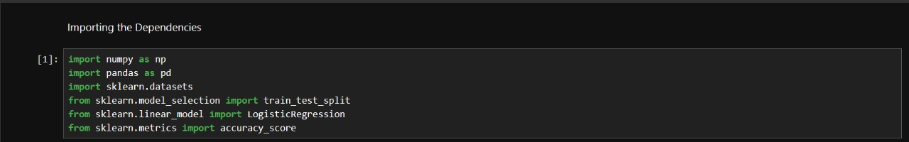

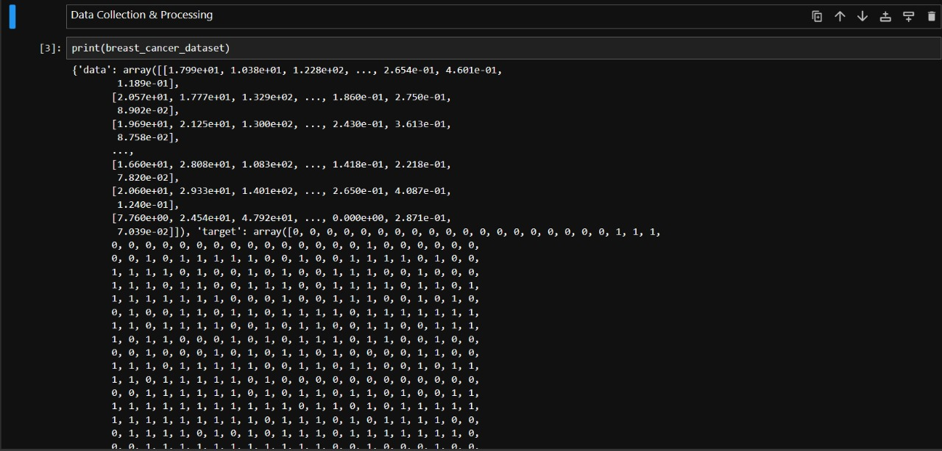

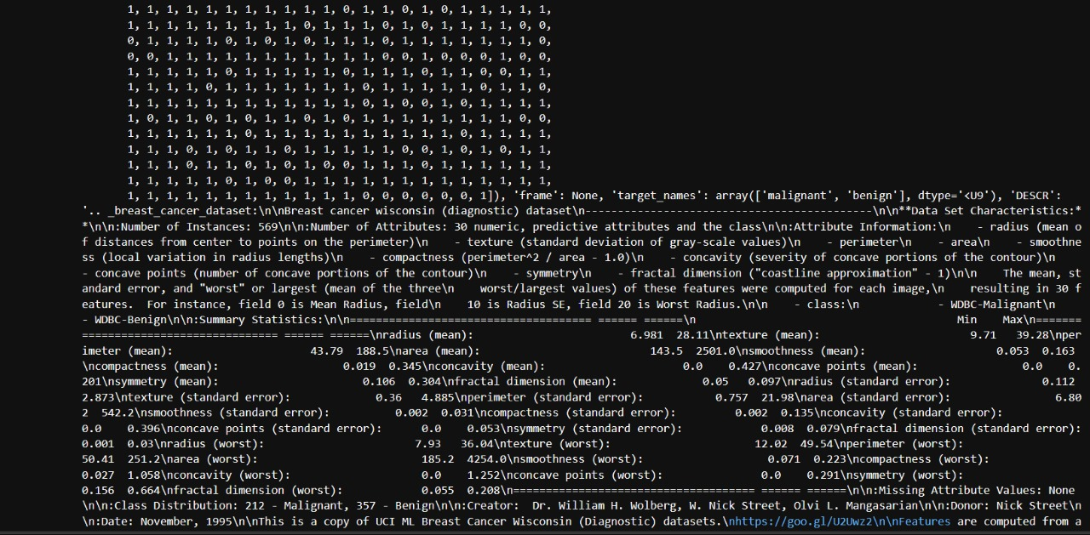

**Department of CSE, GST, Bengaluru**

**2023-2024**

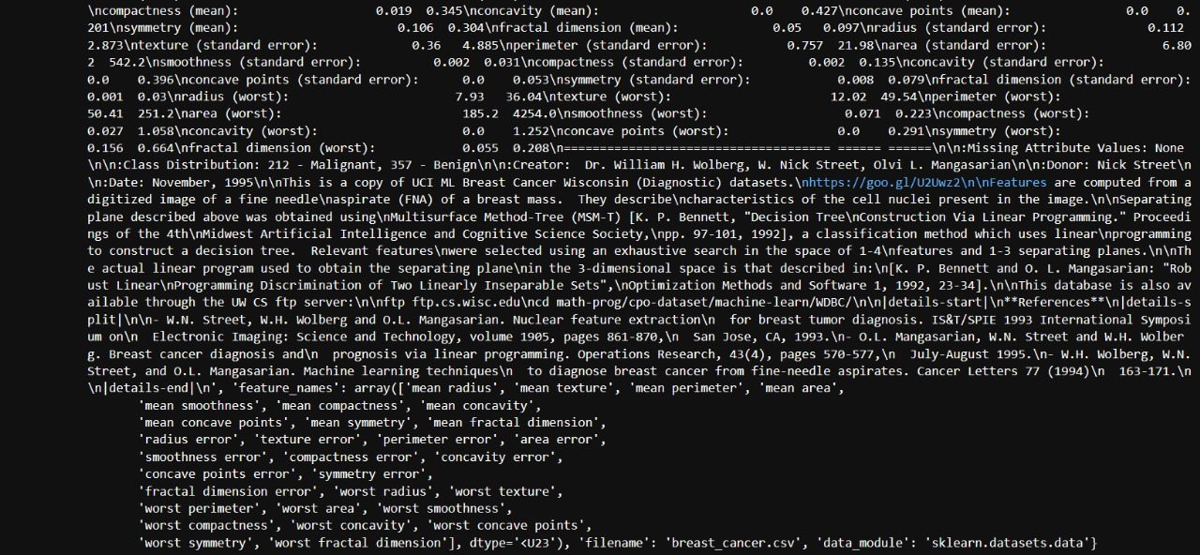



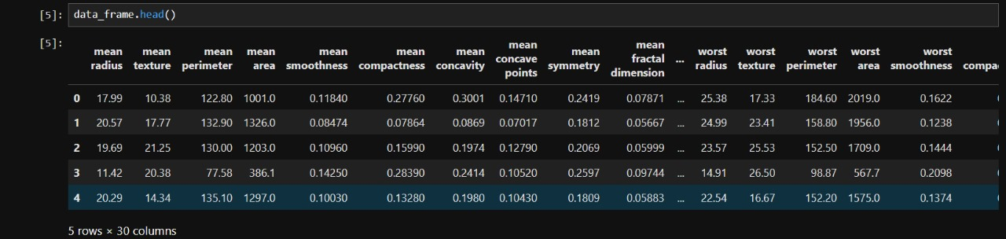



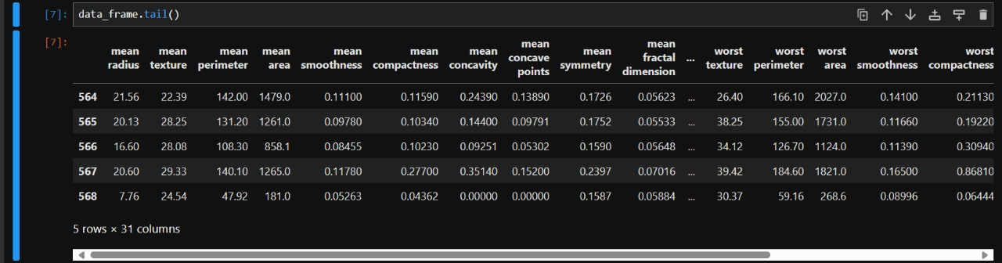



**2023-2024**

**Department of CSE, GST, Bengaluru**

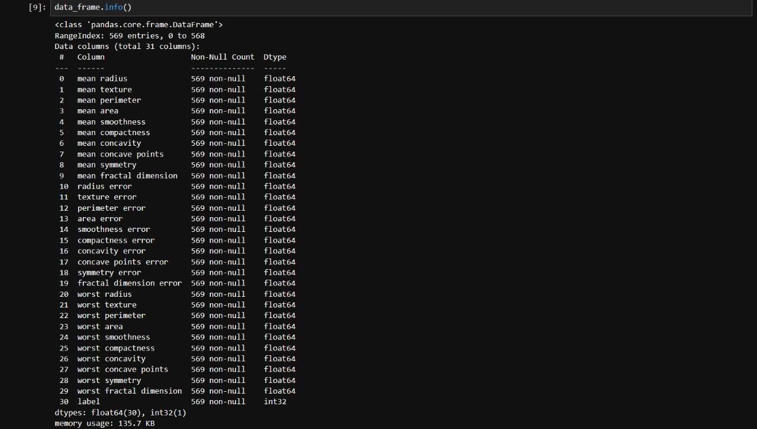

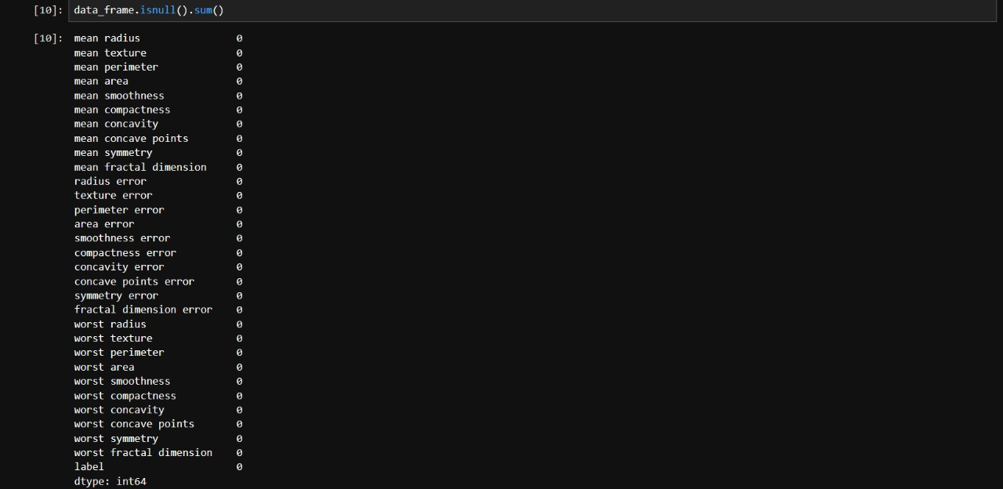

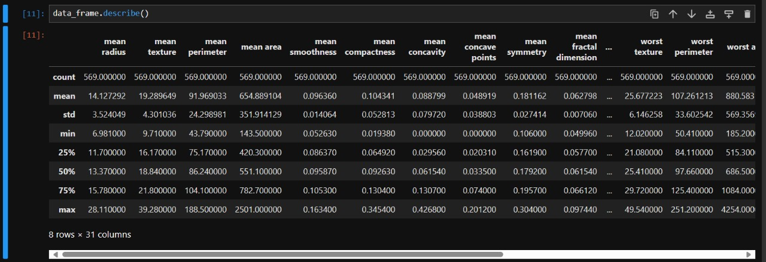

**2023-2024**

**Department of CSE, GST, Bengaluru**

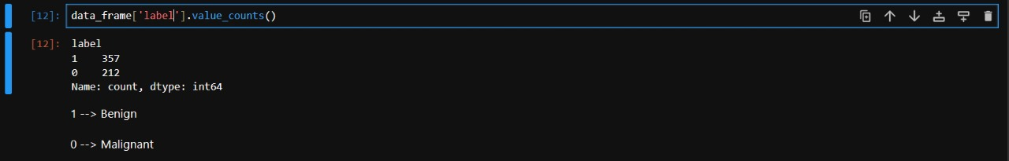

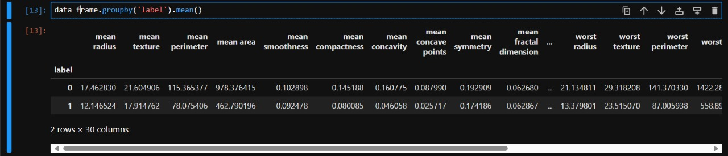



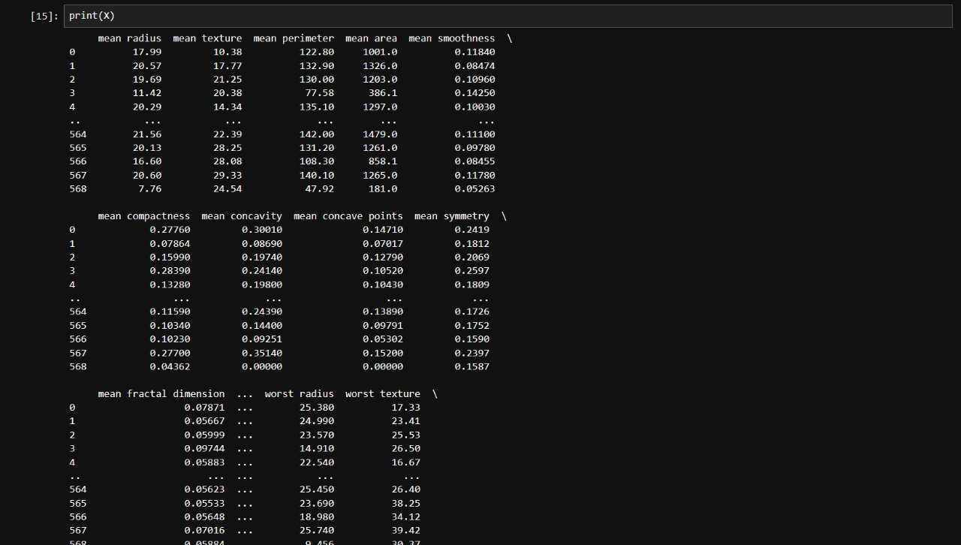

**Department of CSE, GST, Bengaluru**

**2023-2024**

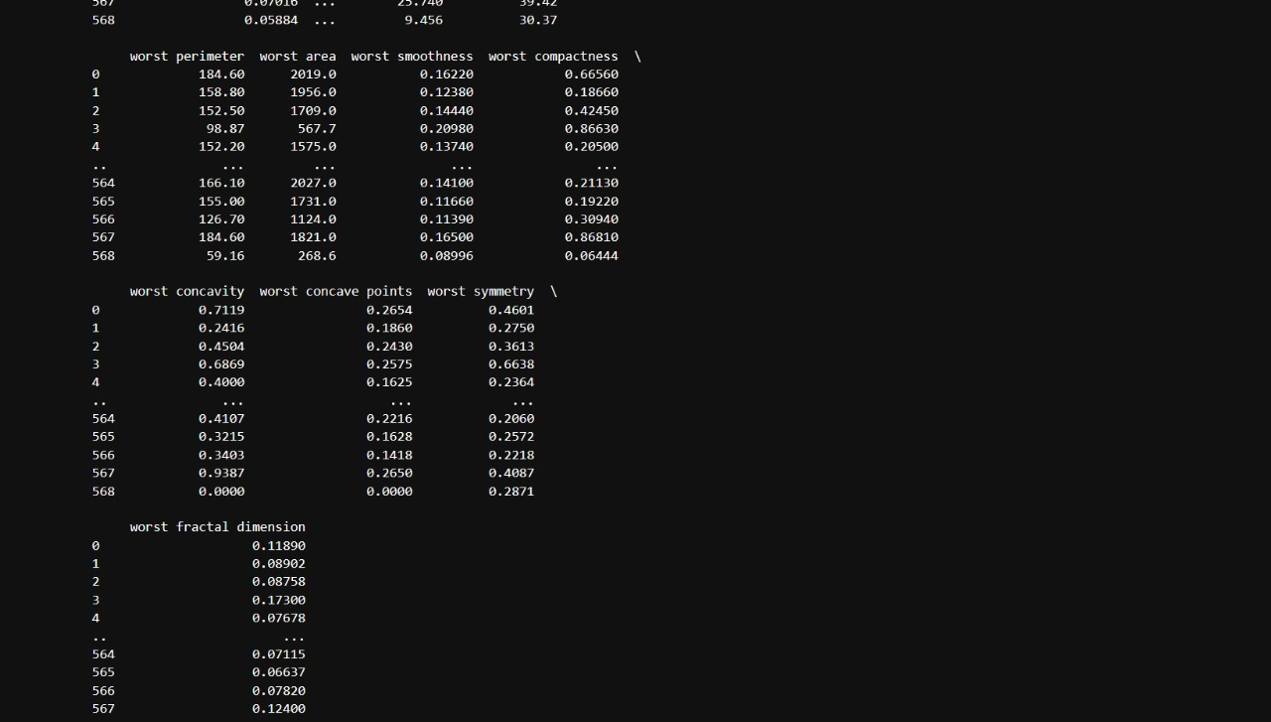

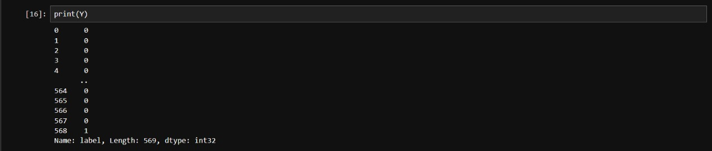





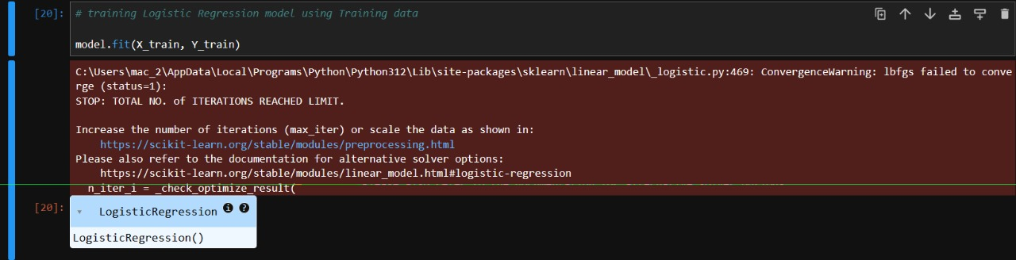

**2023-2024**

**Department of CSE, GST, Bengaluru**

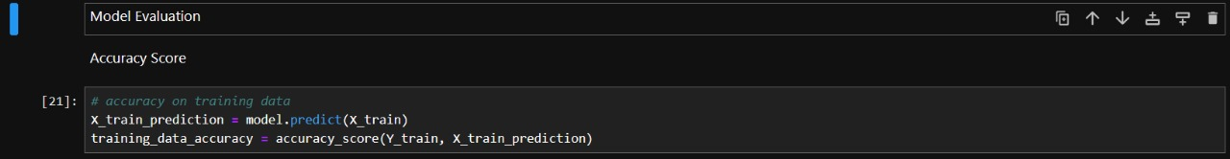







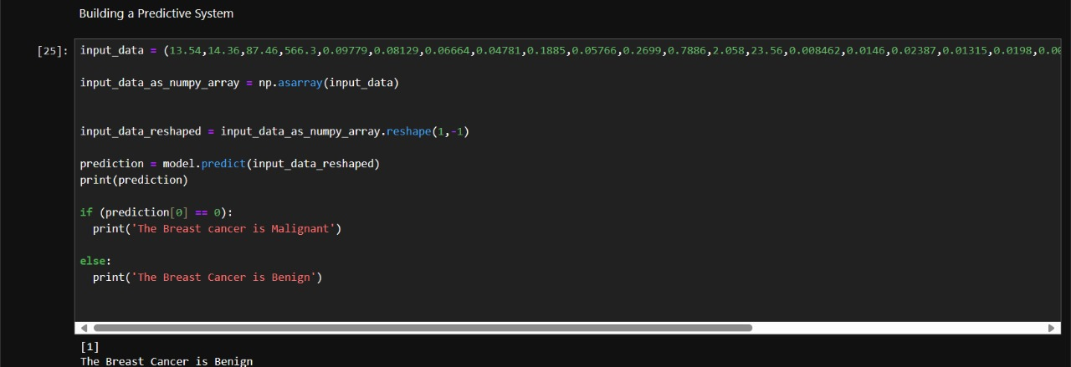

**2023-2024**

**Department of CSE, GST, Bengaluru**

**2023-2024**

**Department of CSE, GST, Bengaluru**

**8. PROGRAM CODE**

import numpy as np

import pandas as pd

import sklearn.datasets

from sklearn.model_selection import train_test_split

from sklearn.linear_model import LogisticRegression

from sklearn.metrics import accuracy_score

breast_cancer_dataset = sklearn.datasets.load_breast_cancer()

print(breast_cancer_dataset)

data_frame = pd.DataFrame(breast_cancer_dataset.data, columns = breast_cancer_dataset.feature_names)

data_frame.head()

data_frame['label'] = breast_cancer_dataset.target

data_frame.tail()

data_frame.shape

data_frame.info()

data_frame.isnull().sum()

data_frame.describe()

data_frame['label'].value_counts()

data_frame.groupby('label').mean()

X = data_frame.drop(columns='label', axis=1)

Y = data_frame['label']

print(X)

print(Y)

X_train, X_test, Y_train, Y_test = train_test_split(X, Y, test_size=0.2, random_state=2)

print(X.shape, X_train.shape, X_test.shape)

model = LogisticRegression()

# training Logistic Regression model using Training data

model.fit(X_train, Y_train)

# accuracy on training data

X_train_prediction = model.predict(X_train)

training_data_accuracy = accuracy_score(Y_train, X_train_prediction)

print('Accuracy on training data = ', training_data_accuracy)

# accuracy on test data

X_test_prediction = model.predict(X_test)

test_data_accuracy = accuracy_score(Y_test, X_test_prediction)

print('Accuracy on test data = ', test_data_accuracy)

input_data=

(13.54,14.36,87.46,566.3,0.09779,0.08129,0.06664,0.04781,0.1885,0.05766,0.2699,0.7886,2.058,23.56,0.008462,0.0146,0.02387,0.01315,0.0198,0.0023,15.11,19.26,99.7,711.2,0.144,0.1773,0.239,0.1288,0.2977,0.07259)

input_data_as_numpy_array = np.asarray(input_data)

input_data_reshaped = input_data_as_numpy_array.reshape(1,-1)

prediction = model.predict(input_data_reshaped)

print(prediction)

if (prediction[0] == 0):

print('The Breast cancer is Malignant')

else:

print('The Breast Cancer is Benign')

**Department of CSE, GST, Bengaluru**

**2023-2024**

**9. EXPERIMENTAL RESULTS**

Code Output: The Breast Cancer is Benign.

This code implements a logistic regression model for classifying breast cancer as malignant or benign using the popular breast cancer dataset from sklearn. It begins by loading the dataset, creating a Data Frame, and preprocessing the data. The dataset comprises various features such as mean radius, mean texture, and mean perimeter, among others. After splitting the data into training and testing sets, a logistic regression model is trained on the training data. The accuracy of the model is evaluated on both the training and testing datasets. Finally, a sample input data point is provided to the trained model to predict whether the corresponding breast cancer is malignant or benign. This implementation outputs the accuracy of the model on both training and testing data and predicts the nature of the provided breast cancer data point, categorizing it as either malignant or benign.

**Department of CSE, GST, Bengaluru**

**2023-2024**

**10. Conclusion**

This project concludes that an efficient deep neural network (DNN) can be used to classify breast cancer with high accuracy. We have tested 10 well known models on the data set collected from dataset, "Categorized Digital Database for Low energy and Subtracted Contrast Enhanced Spectral Mammography images". The performance metrics like accuracy, f1 score, precision and recall score are calculated and recorded for comparison to choose the best model. We have observed that Inception V2 is the best performer among all the models. Although Inception V2 performs the best, it is prone to over-fitting. In order to improve the model performance we have used methodologies like Dropout and Weight Decay. We have tested the model on the validation dataset.

The proposed DNN architecture is designed to extract relevant features from medical images and classify them into benign or malignant categories. The model was trained using a large dataset of breast cancer images and achieved high accuracy on the test set. The use of dropout and weight decay techniques further improved the performance of the model. In the future, this DNN can be integrated into clinical practice to assist medical professionals in making accurate diagnoses and improving patient outcomes.

**2023-2024**

**Department of CSE, GST, Bengaluru**

**11. FUTURE WORK**

In the field of medicine, Deep Neural Network (DNN) architecture has a number of benefits. One of its main benefits is its capacity to quickly and accurately process and analyse massive amounts of complicated data, including patient records and medical picture data. In order to help with the diagnosis and treatment of various medical disorders, DNNs are able to recognise subtle patterns and features in data that may be challenging for people or conventional machine learning algorithms to notice.

DNNs are useful for jobs like forecasting patient outcomes and drug discovery because they can learn from new data and adapt to it. Additionally, the usage of DNNs in medical research can aid in the discovery of novel biomarkers and therapeutic targets, resulting in the creation of more effective and individualized patient therapies. DNN architecture has the ability to fundamentally alter how medical practitioners identify and treat diseases while also enhancing patient outcomes.

In this work we have tested 10 well-known and most used DNN architectures on a MR image dataset of breast cancer patients. The performance metrics are recorded and the best model, Inception V2 has been chosen for improvement. Considering Inception V2, it introduces the features of multiple convolutional layers with multiple filter sizes and the feature of batch normalization. Although being able to perform better than other models, Inception V2 is hugely vulnerable to over-fitting, which reduces the accuracy from increasing. In order to reduce overfitting, we have used dropout layers and weight decay features. This has made the model improve the model performance and reduces over-fitting in Inception V2.

In future, Inception V2 can be much more developed in its architecture by adding skip connection s between the inception modules. The skip connections help the model to preserve the gradient and help improve model by reducing vanishing gradient. The skip connections also help to extract features from the dataset much finer and help share the features between different layers. This helps to classify data much better.[35]

**2023-2024**

**Department of CSE, GST, Bengaluru**

**REFERENCES**

1. Al-Dhabyani W, Gomaa M, Khaled H, Fahmy A (2020) Dataset of breast ultrasound images. Data Br 28:104863.

2. American Cancer Society (2019) "Breast cancer facts & fgure," Am Cancer Soc 70(8): 515-517.

3. Atrey K, Singh BK, Roy A, Bodhey NK (2020) "Breast cancer detection and validation using dual modality imaging, 454-458,

4. Cai L, Wang X, Wang Y, Guo Y, Yu J, Wang Y (2015) Robust phase-based texture descriptor for classifcation of breast ultrasound images. Biomed Eng.

5. Krizmaric, M.; Mertik, M. Application of Bayesian networks in emergency medicine. In Central European Conference on Information

and Intelligent Systems; IOP Publishing: Bristol, UK, 2008.

6. Nguyen, C.; Wang, Y.; Nguyen, H.N. Random forest classifier combined with feature selection for breast cancer diagnosis and

prognostic. J. Biomed. Sci. Eng. 2013, 06, 551–560. [CrossRef]

7. Sharma, S.; Aggarwal, A.; Choudhury, T. Breast cancer detection using machine learning algorithms. In Proceedings of the 2018

8. International Conference on Computational Techniques, Electronics and Mechanical Systems (CTEMS), Belgaum, India, 21–22

December 2018.

**Department of CSE, GST, Bengaluru**

**2023-2024**